**SENTINEL ROVER**

**A SMART SURVEILLANCE SYSTEM**

**EMBEDDED SYSTEMS**

**MINIPROJECT REPORT**

***Submitted by***

|  |  |
| --- | --- |
| **S.NISHANTH** | **22EC13** |
| **S.SOWMIYA** | **22EC43** |
| **C.SUBAVENI** | **22EC45** |
| **S.NIVETHA** | **22EC16** |

***in partial fulfilment for the award of the degree of***

**BACHELOR OF ENGINEERING**

**IN**

**ELECTRONICS AND COMMUNICATION ENGINEERING**



**ANNA UNIVERSITY, CHENNAI**

**KARPAGAM INSTITUTE OF TECHNOLOGY**

(Autonomous)

**COIMBATORE – 641 105**

**SENTINEL ROVER**

**A SMART SURVEILLANCE SYSTEM**

|  |  |
| --- | --- |
| **S.NISHANTH** | **22ECB13** |
| **S.SOWMIYA** | **22ECB43** |
| **C.SUBAVENI** | **22ECB45** |
| **S.NIVETHA** | **22ECB16** |

Dissertation submitted in partial fulfilment of the requirements for the degree of

**BACHELOR OF ENGINEERING**

**IN**

**ELECTRONICS AND COMMUNICATION ENGINEERING**

of Anna University, Chennai

**JANUARY 2025**

...…………………… …………..……………….

Faculty guide Head of the Department



Certified that the candidate was examined in the viva-voce examination held on

………………….

…………………….. …………………………..

(Internal Examiner) (External Examiner)

**ACKNOWLEDGEMENT**

We would like to show our gratitude to the management of Karpagam Institute Of Technology **Dr. R. Vasanthakumar, BE., (Hons), D.Sc.**Chairman and Managing Trustee, Karpagam Educational Institutions for providing us with all sorts of supports in completion of this project.

We express our sincere and profound gratitude to our Principal

**Dr. P. Manimaran, Ph.D.,** for his guidance and sustained encouragement for the successful completion of this project.

We feel immense pleasure in expressing our humble note of gratitude to our Head of the Department **Dr. D.Baskar, M.E., Ph.D.,** for his remarkable guidance and besides his positive approach he has offered incessant help in all possible way from the beginning.

We are thankful to our project coordinator **Mrs.S.Ramya** **ME.,(Ph.D),**Assistant Professor, Department of Electrical and Electronics Engineering for her valuable suggestions and guidance throughout the arise in the course of the project.

We also extend our thanks to other faculty members, parents and friends for providing their moral support in successfully completing this project.

**SENTINEL ROVER**

**ABSTRACT:**

The Sentinel Rover is a compact yet efficient surveillance system designed to provide real-time monitoring in various environments. It is built using a Node MCU microcontroller, an ESP32-CAM module for image processing, a small display for status updates, and a robust 30 RPM motor controlled by an L298N motor driver for precise navigation. The Node MCU acts as the main wireless communication hub. The ESP32-CAM captures high-definition images, which are then processed locally to analyze and detect important features or anomalies, making the rover ideal for surveillance in areas with limited or dangerous access. The L298N motor driver helps the rover move across all terrains by regulating the 30 RPM motors efficiently. It also displays some necessary information such as connectivity status and battery level to enhance user experience. This project combines affordability, portability, and functionality, making it suitable for applications such as security monitoring, disaster response, and exploration in areas inaccessible to humans. Future improvements may include integrating AI for object detection and night vision capabilities, further expanding the rover's potential applications. The Sentinel Rover is a step toward accessible and versatile surveillance technology.

**TABLE OF CONTENTS**

|  |  |  |
| --- | --- | --- |
| **CHAPTER NO** | **TITLE** | **PAGENO** |
|  | **ABSTRACT** | **i** |
|  | **LIST OF FIGURE** | **vi** |
| **1** | **INTRODUCTION** | **1** |
|  | 1.1 Introduction to the Project | 1 |
| **2** | **PROJECT MODULES** | **5** |
|  | 2.1 Block Diagram of the Project | 5 |
|  | 2.2 ESP32-CAM | 6 |
|  | 2.2.1 General Description | 6 |
|  | 2.2.2 Key Features of the ESP32-CAM | 7 |
|  | 2.2.2.1 Video Streaming Capability | 7 |
|  | 2.2.2.2 Wi-Fi Connectivity  2.2.2.3 Image processing  2.2.2.4 Low Power Consumption | 7  7  8 |
|  | 2.2.3 Pin Configuration  2.2.4 I/O Ports | 9  9 |
|  | 2.2.4.1 Communication Interface | 9 |
|  |  |  |
|  | 2.2.4.2 GPIO Ports | 10 |
|  | 2.2.5 ESP32-CAM Architecture | 11 |
|  |  |  |
|  |  |  |
|  | 2.3 Node MCU | 13 |
|  |  |  |
|  | 2.3.1 General Description | 13 |
|  |  |  |
|  | 2.3.2 Key Features | 14 |
|  |  |  |
|  | 2.4 L298N Motor Driver | 18 |
|  | 2.4.1 Motor Control and Power Supply  2.4.2 Key Features | 18  20 |
|  | 2.5 30 RPM Motors | 22 |
|  | 2.6 Power Supply Unit | 23 |
|  | 2.6.1 Battery Power System | 24 |
|  | 2.6.2 Voltage Regulation and Distribution | 26 |
|  | 2.7 LCD Display Module | 28 |
|  | 2.7.1 Introduction | 28 |
|  | 2.7.2 Functionality and Interface | 28 |
|  |  |  |
| **3** | **DESIGN AND** **IMPLEMENTATION** | **30** |
|  |  |  |
|  | 3.1Software Implementation | 30 |
|  |  |  |
|  | 3.1.1 Front-End Design | 30 |
|  |  |  |
|  | 3.1.2 Data Communication and Control  3.1.3 Open CV | 32  34 |
|  | 3.2 Hardware Implementation | 35 |
|  |  |  |
|  | 3.2.1 Design of the Project | 35 |
|  | 3.2.1.1 Circuit Diagram | 37 |
| **4** | 3.2.1.2 Working of Circuit  3.2.2 Implementation of the Project    **CONCLUSION AND FUTURE ENHANCEMENT** | 38  40  **41** |
|  | 4.1 Conclusion  4.2 Future Enhancement  REFERENCES | 41  41  42 |
|  |  |  |
|  |  |  |
|  |  |  |
|  |  |  |
|  |  |  |
|  | **LIST OF FIGURES** |  |
| **FIG NO.** | **FIGURE NAME** | **PAGE NO** |
| **2.1** | Block Diagram | 5 |
| **2.2** | ESP32-CAM Module | 6 |
| **2.2.3** | Pin Diagram | 9 |
| **2.2.5** | ESP32-CAM Architecture | 12 |
| **2.3.1** | Connection Representation | 14 |
| **2.4.1** | L298N Motor Driver | 18 |
| **2.6.1** | Buck Converter | 26 |
| **2.7.2** | LCD | 29 |
| **3.1.1** | Front End Design | 31 |
| **3.2.1.1** | Circuit Diagram | 37 |
| **3.2.2** | Implementation Of The Project | 40 |
|  |  |  |
|  |  |  |
|  |  |  |

**CHAPTER 1**

**INTRODUCTION**

**1.1 Introduction to the Project:**

The **Sentinel Rover** project is conceived as a cutting-edge mobile surveillance system designed to enhance security measures in areas where conventional surveillance methods may fall short. Its primary goal is to provide real-time, remote monitoring capabilities in environments that are difficult to access or hazardous for human presence. As security and surveillance needs continue to evolve, traditional stationary cameras or sensors often struggle to cover large or dynamic areas effectively. This project aims to address these challenges by offering a versatile, autonomous solution that combines mobility, video streaming, and remote operation.

In the realm of modern security, the ability to gather information in real-time is critical. Conventional security systems, such as fixed CCTV cameras, are limited in their coverage and are often restricted to fixed locations. These systems lack the flexibility required for active monitoring across a wide range of environments, especially in places with complex or dangerous terrain. For instance, monitoring remote or hazardous areas like disaster zones, construction sites, or places where human presence is prohibited due to safety risks, requires a more adaptable and dynamic solution. The **Sentinel Rover** fills this gap by providing an all-in-one, mobile surveillance unit that can be deployed to navigate through various environments while offering continuous video feeds to a remote operator.

The **Sentinel Rover** uses advanced technologies that allow it to autonomously navigate through different terrains, ensuring that it can reach areas where stationary cameras would be ineffective. By integrating a wireless communication system, the rover can transmit live video streams to an operator's device, allowing for immediate feedback and action. This real-time video feed is crucial for security personnel or operators to make quick, informed decisions when monitoring critical areas. The rover's ability to move freely across terrains like dirt, gravel, grass, or even slight inclines further ensures that surveillance operations remain uninterrupted, even in challenging environments.

One of the standout features of the **Sentinel Rover** is its affordability, making it an attractive option for a wide range of applications. Traditional surveillance solutions, particularly those involving drones or unmanned aerial vehicles (UAVs), can be costly and may require specialized training to operate. In contrast, the **Sentinel Rover** is a cost-effective alternative that provides similar capabilities in terms of mobility and surveillance, without the hefty price tag associated with more complex systems. This accessibility makes the **Sentinel Rover** an ideal tool not just for professional security companies, but also for smaller businesses, individuals, or even local authorities who need a reliable surveillance solution without breaking the bank.

The rover is designed to be intuitive and user-friendly, enabling easy control and operation through a mobile app or PC interface. Users can issue commands remotely to control the rover’s movements, whether to move forward, backward, turn, or stop, ensuring that they can adjust the rover’s position based on the live video feed they are receiving. This combination of mobility and control is especially important for dynamic surveillance situations, where the operator needs to adjust the rover’s position or navigate to new locations to get a better view of the area being monitored.

Another significant advantage of the **Sentinel Rover** is its real-time video streaming capability, which is powered by the **ESP32-CAM module**. This module allows the rover to stream high-definition video feeds over Wi-Fi, providing a clear view of the surroundings to the operator, no matter how far the rover is from the control station. This capability is invaluable in situations such as monitoring construction sites, tracking security threats, or assessing the aftermath of natural disasters. The rover’s ability to capture and transmit video instantly provides users with actionable information that can be used to address security concerns, identify hazards, or assist in rescue efforts.

The flexibility of the **Sentinel Rover** extends beyond security applications. It has the potential to be utilized in a wide array of industries, including emergency response, surveillance for environmental monitoring, military reconnaissance, and even exploration. In emergency situations, such as during natural disasters or search-and-rescue missions, the rover can be deployed to navigate through hazardous areas to locate victims or assess the situation. Similarly, environmental scientists could use the rover for remote monitoring of wildlife, vegetation, or other ecological conditions in hard-to-reach regions.

Moreover, the **Sentinel Rover** is designed to be easily customizable and scalable, meaning future enhancements can be integrated to further expand its functionality. Potential improvements could include the addition of AI-powered systems for object detection, which would allow the rover to autonomously identify people, vehicles, or other objects of interest. Night vision or thermal imaging could be incorporated to improve the rover's performance in low-light conditions, enabling it to operate effectively even after dark. Furthermore, advancements in battery technology could extend the rover’s operational time, allowing it to stay in the field longer without needing to return for a recharge.

The **Sentinel Rover** project represents a significant leap forward in surveillance technology, offering a mobile, versatile, and affordable alternative to traditional monitoring systems. By combining powerful features like real-time video streaming, mobility, and ease of use, the rover can be deployed in a variety of applications, from security and emergency response to environmental monitoring and exploration. As technology continues to advance, the potential for expanding the rover's capabilities is vast, ensuring that it remains a valuable tool for those who require reliable and efficient surveillance solutions in a variety of scenarios.

By incorporating cutting-edge features such as remote monitoring, real-time data transmission, and autonomous navigation, the Sentinel Rover pushes the boundaries of traditional surveillance systems. Its compact and adaptable design allows it to access areas that are otherwise difficult or unsafe for humans, making it an invaluable tool for applications ranging from disaster management to industrial inspections.

This project not only highlights the increasing importance of integrating technology into everyday security systems but also demonstrates how accessibility and functionality can go hand-in-hand. The **Sentinel Rover** is a powerful example of how technology can be leveraged to enhance security, improve decision-making, and provide innovative solutions for complex problems, all while maintaining ease of use and affordability.

**CHAPTER 2**

**PROJECT MODULES**

**2.1 Block Diagram of the Project:**

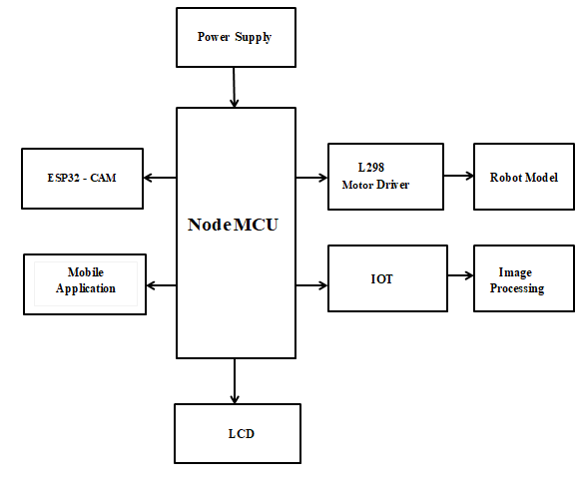

Fig No 2.1 Block Diagram

**2.2 ESP Controller:**

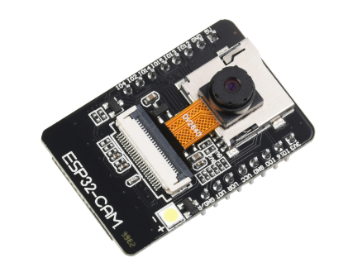

Fig No 2.2 ESP32 CAM Module

**2.2.1 General Description:**

The Sentinel Rover is a versatile surveillance robot designed for monitoring and reconnaissance purposes in various environments. Derived from modern robotics and IoT technologies, it integrates compact design and advanced functionalities for efficient operation. The term "Sentinel Rover" signifies its capability to perform discreet observation and data gathering.

Sentinel Rovers are popular among developers and hobbyists alike due to their adaptability, affordability, and wide range of applications. They feature low-cost components, an active developer community, extensive documentation, and support for wireless control. The rover uses a combination of cameras, sensors, and microcontrollers for navigation, data collection, and remote communication.

**2.2.2 Key Features of ESP32-CAM:**

**2.2.2.1 Video Streaming Capabilities:**

* Supports real-time video streaming with resolutions up to UXGA (1600x1200).
* Equipped with an OV2640 camera for high-quality image capture.
* Capable of JPEG compression for efficient image and video transmission.
* Supports motion detection and face recognition for advanced surveillance applications.
* Video output can be transmitted directly to web servers or cloud platforms for remote access.

**2.2.2.2 Wi-Fi Connectivity:**

* Built-in 802.11b/g/n Wi-Fi module for wireless communication.
* Allows remote monitoring and control via smartphone or cloud applications.
* Supports Access Point (AP) and Station (STA) modes for flexible network configurations.
* Facilitates over-the-air (OTA) firmware updates for easy device maintenance.
* Compatible with popular IoT platforms like AWS IoT, Google Cloud, and Firebase.

**2.2.2.3 Image Processing:**

The Sentinel Rover utilizes OpenCV, an open-source computer vision library, for image processing and environmental analysis. OpenCV enables the rover to perform tasks such as motion detection, edge detection, and pattern recognition efficiently. By leveraging its powerful algorithms, the system processes sensor data and imagery locally to identify changes or anomalies in real-time.

The processed data is managed by the Node MCU, which relays critical information to the user interface for decision-making. OpenCV’s flexibility allows for seamless integration of additional features, such as object tracking and environmental mapping, making the rover adaptable for various applications like security, disaster response, and exploration. The use of OpenCV ensures a robust and scalable system, ready for future enhancements, such as incorporating AI-based recognition for more advanced functionality.

**2.2.2.4 Low Power Consumption:**

* Ultra-low power consumption design, ideal for battery-operated applications.
* Includes deep sleep mode with power usage as low as 5 µA.
* Optimized for portable and energy-efficient IoT solutions.
* Offers adjustable power modes to balance performance and energy savings.
* Suitable for solar-powered and long-term remote deployments with minimal recharging.

**2.2.3 PIN Configuration:**

The Sentinel Rover's pin configuration connects the ESP32-CAM, Node MCU, and L298N Motor Driver for seamless communication and motor control.

Each component is assigned GPIO pins for movement, Video streaming and power management

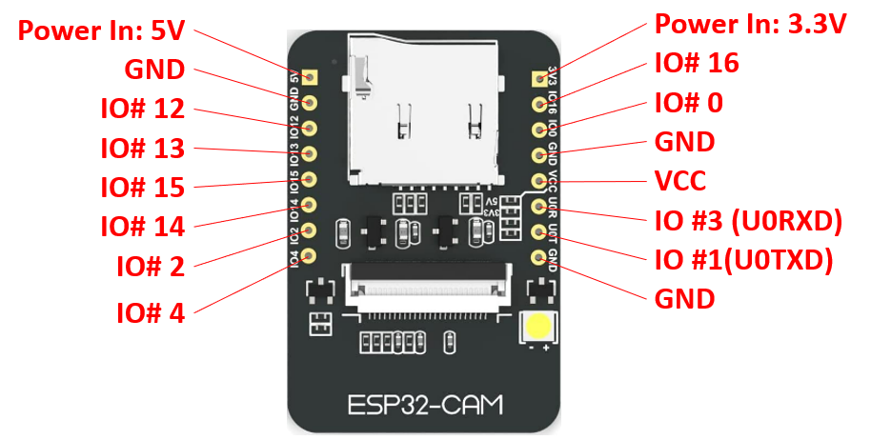

Fig No 2.2.3 Pin Diagram

**2.2.4 I/O Ports:**

**2.2.4.1 Communication Interfaces:**

* **UART (Universal Asynchronous Receiver/Transmitter):** Supports serial communication for debugging and external device interfacing.
* **SPI (Serial Peripheral Interface):** Provides high-speed communication with external devices such as sensors, displays, and memory modules.
* **I2C (Inter-Integrated Circuit):** Facilitates communication with multiple sensors and peripherals using a two-wire protocol.
* **Wi-Fi Connectivity:** Enables wireless communication for transmitting data to remote servers or cloud platforms.
* **MicroSD Interface:** Supports external memory expansion for data logging and video recording.
* **I2S (Inter-IC Sound):** Provides an interface for audio processing, enabling connection with microphones or audio outputs.
* **Bluetooth 4.2 LE (Low Energy):** Allows short-range wireless communication for IoT applications and data exchange.
* **CAN Bus:** Supports integration with industrial and automotive communication networks.
* **Ethernet Connectivity (via external module):** Enables wired communication for enhanced reliability in data transfer.
* **Front-End Interface**: The user’s mobile or PC app communicates with the Node MCU over Wi-Fi, allowing for real-time control of the rover's movements. The interface displays live feedback, including status updates and the processed results from image analysis, enhancing the overall user experience.

**2.2.4.2 GPIO Ports:**

* Provides up to **10 programmable GPIO pins** for interfacing with external devices such as LEDs, sensors, or motors.
* Supports **ADC (Analog-to-Digital Conversion):** Enables the reading of analog sensor inputs.
* Includes **PWM (Pulse Width Modulation):** Controls servo motors and LED brightness.
* Configurable for **digital input, output, or interrupt functionality,** enabling responsive operations.
* **Capacitive Touch Support:** Allows integration of touch-sensitive interfaces for user interaction.
* Supports multiple GPIO modes simultaneously, ensuring flexibility for complex systems.
* **Interrupt Handling:** GPIO pins can be configured to trigger interrupts for real-time event detection.
* **DAC (Digital-to-Analog Conversion):** Converts digital signals to analog outputs, useful for audio and signal control.
* **Open-Drain Output Support:** Enables communication with devices requiring open-drain configurations.

**2.2.5 ESP32-CAM Architecture:**

* **Microcontroller Core:** Dual-core Xtensa LX6 processor with clock speeds up to 240 MHz for fast and reliable processing.
* **Memory:** Integrated 520 KB SRAM and 4 MB Flash memory, expandable via external SPI Flash or PSRAM for demanding applications.
* **Camera Module:** Equipped with an OV2640 camera for high-resolution image and video capture with support for face recognition and motion detection.
* **Wireless Module:** Built-in 802.11 b/g/n Wi-Fi and Bluetooth 4.2 for robust connectivity, enabling IoT and smart device integration.
* **Power Management:** Supports low-power modes, such as deep sleep and light sleep, for energy-efficient operations.
* **Peripheral Interfaces:** Includes UART, SPI, I2C, I2S, and GPIO interfaces for seamless integration with sensors, actuators, and other hardware.
* **Integrated Voltage Regulator:** Ensures efficient power supply management, reducing the need for external components.
* **Onboard Clock System:** Provides synchronized and precise operations for time-sensitive tasks.
* **Security Features:** Hardware encryption ensures secure data transmission and protection against unauthorized access.

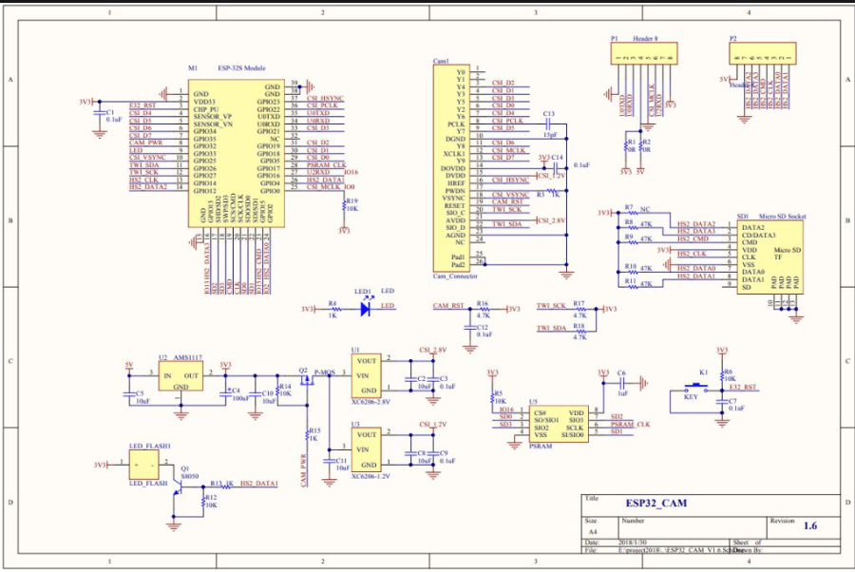

Fig No 2.2.5 ESP32 CAM Architecture

### 2.3 Node MCU

#### 2.3.1 General Description

* The Node MCU, built around the ESP8266 Wi-Fi module, is a cost-effective and highly integrated platform for IoT applications.
* It supports easy programming via the Arduino IDE and provides reliable Wi-Fi connectivity for seamless communication with other devices.
* In the Sentinel Rover, it bridges the user's commands with motor actions and integrates the video feed from the ESP32-CAM.

Programming the Node MCU is straightforward, as it supports the Arduino IDE, a widely used development environment.

* This allows both beginners and experienced developers to write, upload, and debug code with ease, ensuring rapid prototyping and development.
* Its compatibility with Lua scripts further enhances its versatility for more advanced applications.
* In the Sentinel Rover, the Node MCU acts as the central controller, orchestrating the communication and operation of key components.
* It bridges the user’s commands—sent via a smartphone or PC over a Wi-Fi network—with the physical actions of the rover, such as forward or backward movement, turning, or stopping.
* These commands are processed by the Node MCU, which generates precise control signals sent to the L298N motor driver to control the DC motors.

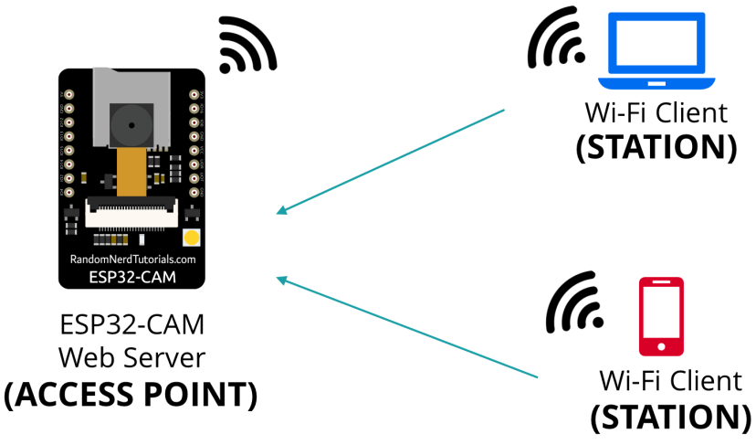

Fig No 2.3.1 Connection Representation

### 2.3.2 Key Features

**Wi-Fi Capability:**

* Equipped with 802.11 b/g/n Wi-Fi support, the Node MCU ensures reliable and stable communication with smartphones or PCs.
* Enables real-time data transfer, allowing seamless operation of IoT systems like the Sentinel Rover.
* Provides support for access point (AP) and station (STA) modes, enabling flexible network configurations.
* The built-in Wi-Fi antenna ensures extended coverage and robust connectivity in various environments.

**GPIO Support:**

* Features 11 versatile GPIO pins that can be configured for digital or analog input/output operations.
* The pins support advanced functionalities like PWM (Pulse Width Modulation), ADC (Analog-to-Digital Conversion), and communication protocols such as I2C, SPI, and UART.
* Enables easy integration with peripheral devices such as motor drivers, sensors, and display modules.
* GPIO pins can be programmed for multitasking, offering flexibility for complex operations in the Sentinel Rover.

**PWM Support:**

* Provides precise control over motor speed and direction, ensuring smooth movement of the DC motors.
* PWM signals are generated by the Node MCU and sent to the L298N motor driver for efficient motor operation.
* This feature enables the Sentinel Rover to perform fine movements, navigate obstacles, and adjust speeds dynamically.
* The capability to adjust duty cycles ensures efficient power usage for prolonged battery life.

**Compact and Lightweight:**

* The small form factor of the Node MCU makes it ideal for integration into compact systems like the Sentinel Rover.
* Lightweight design minimizes the overall weight of the rover, enhancing its mobility and energy efficiency.
* Compactness does not compromise functionality, making it suitable for space-constrained designs.
* Perfect for portable surveillance devices that require high performance in a minimal footprint.

**Integrated Voltage Regulator:**

* The onboard voltage regulator ensures the Node MCU operates efficiently within a wide input voltage range (3.3V–5V).
* Provides stable power supply to connected components, preventing voltage fluctuations from affecting system performance.
* Protects sensitive components from overvoltage or undervoltage, increasing the overall reliability of the system.
* Enables direct battery connection, simplifying the power management design for mobile applications.

**Flash Memory:**

* Includes 4 MB of flash memory for storing firmware, configurations, and user-defined programs.
* The non-volatile memory retains data even during power loss, ensuring uninterrupted operation.
* Offers sufficient storage for IoT applications that require large firmware or data logging.
* Supports Over-The-Air (OTA) updates, allowing remote firmware upgrades without physical access.

**Low Power Consumption:**

* Designed for energy-efficient applications, consuming minimal power during operation and in standby mode.
* Ideal for battery-operated systems like the Sentinel Rover, extending the operational time between charges.
* The low-power sleep modes enable prolonged usage without compromising functionality.
* Energy efficiency reduces heat generation, ensuring stable performance even during extended use.

**Programming Flexibility:**

* Fully compatible with the Arduino IDE, allowing easy code development and debugging for all skill levels.
* Supports Lua scripts for advanced programming, catering to developers looking for additional flexibility.
* Enables quick prototyping, reducing development time for IoT and robotics projects.
* The open-source platform fosters a wide range of community support and resources.

**Versatile Communication:**

* Provides built-in support for UART, SPI, and I2C protocols, ensuring seamless interfacing with multiple modules.
* Facilitates efficient communication between the Node MCU, ESP32-CAM, motor driver, and sensors.
* Enables the Sentinel Rover to process commands, capture video feeds, and control movements simultaneously.
* Offers robust communication for real-time surveillance applications, ensuring smooth operation under dynamic conditions.

**2.4 L298N Motor Driver**

**2.4.1 Motor Control and power supply**

The **L298N Motor Driver** is a robust and efficient motor control module designed for driving DC motors, stepper motors, and other inductive loads. The module uses an **H-bridge circuit** to control the direction and speed of motors by managing the voltage applied to them.

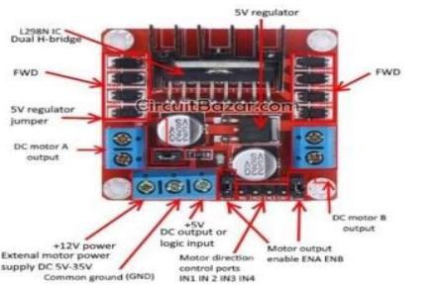

Fig No 2.4.1 L298N Motor Driver

**Motor Control**

* **Direction Control**:
  + The direction of each motor is controlled using two input pins (e.g., IN1/IN2 for Motor A and IN3/IN4 for Motor B).
  + By configuring these input pins with HIGH or LOW signals, the polarity of the motor terminals is adjusted, thereby controlling the direction of rotation.
* **Speed Control**:
  + Speed is regulated using **Pulse Width Modulation (PWM)** on the **ENA** (for Motor A) or **ENB** (for Motor B) pins.
  + A PWM signal with varying duty cycles allows precise speed adjustments for connected motors.
* **Dual Motor Support**:
  + The module can independently control two motors simultaneously, making it suitable for applications like robot navigation.
  + This allows for precise control of movement, including forward, backward, left, and right turns, providing high maneuverability for devices like the Sentinel Rover.

### SPower Supply

* The module requires two separate power supplies:
  1. **Motor Power Supply (Vcc)**:
     + Accepts input voltage between **5V and 46V**, depending on the motor requirements.
     + Provides the necessary current to drive the connected motors.
  2. **Logic Power Supply (Vss)**:
     + Operates at **5V** to power the internal logic of the L298N IC.
     + In some configurations, the module can derive the logic power from the onboard 5V regulator, eliminating the need for an external supply.
* **Current Handling**:
  1. Each channel supports a continuous current of up to **2A** and a peak current of **3A** for short durations.
  2. Includes onboard diodes to protect against back electromotive force (back-EMF) generated by motors.

## 2.4.2 Key Features

The **L298N Motor Driver** has several notable features that make it versatile for motor control applications:

**Features of the Sentinel Rover Motor Driver and Track System**

1. **Dual H-Bridge Circuit**
   * Enables independent control of two DC motors or a single stepper motor.
   * Allows forward, reverse, and stop functionalities for each motor.
2. **Wide Voltage Range**
   * Operates with motor supply voltages between 5V and 46V, making it compatible with a wide range of motors.
3. **High Current Capability**
   * Handles up to 2A continuous current per channel and up to 3A peak current.
4. **PWM Speed Control**
   * Provides efficient speed control using Pulse Width Modulation (PWM) signals on the ENA and ENB pins.**Built-in Protection**
   * Includes flyback diodes to protect the driver circuit from voltage spikes caused by back-EMF during motor operation**.**
5. **Onboard 5V Regulator**
   * Equipped with an onboard voltage regulator and buck converter that can supply 5V logic power to the module or external devices (can be enabled/disabled via jumper).
6. **Thermal Management**
   * Features an aluminium heat sink for effective dissipation of heat generated during high-current operation.
7. **Compact Design**
   * The small form factor makes it ideal for integration into robotic and embedded systems.
8. **Versatile Applications**
   * Suitable for controlling DC motors, stepper motors, and other inductive loads in robotics, automation, and DIY projects.
9. **Easy Interface**
   * Compatible with most microcontrollers like Arduino, Raspberry Pi, and other development boards through straightforward pin connections.
10. **Track Wheel System**
    * Tracks are an excellent alternative to robot wheels.
    * Constructed of polypropylene/rubber, ideal for rough terrain.
    * Lightweight and dependable, with simple assembly.
    * Provides a larger surface area in contact with the ground, reducing the force per unit area compared to wheeled vehicles of the same weight.

**2.5 30 RPM Motors:**

These motors are responsible for providing the rover’s movement, enabling it to move forward, backward, and turn. The 30 RPM (revolutions per minute) rating indicates that the motors rotate at a relatively low speed, which is ideal for this application because it provides controlled and stable movement, essential for remote surveillance in various environments**.**

**Low Speed and High Torque:**

The 30 RPM motors are designed for low-speed operation, which offers high torque at that speed. High torque allows the rover to carry heavier loads (such as the camera, motors, and other components) and move with stability, even on uneven or rough terrain.

Low-speed operation also helps with precision when navigating, reducing the risk of the rover moving too quickly or erratically, which is especially important during remote surveillance where fine control is often needed.

**Smooth and Stable Movement**:

The slower speed provides smoother transitions between movements (e.g., forward to backward or left to right), which makes the rover more reliable for use in surveillance tasks. This is essential for tasks like inspecting specific locations or staying still for video recording.

Compatibility with L298N Motor Driver:

The L298N Motor Driver is designed to handle DC motors like the 30 RPM motors efficiently. It allows for smooth forward/backward motion and the ability to control turning via differential steering (independent control of each motor’s speed and direction).Because the 30 RPM motors provide stable, low-speed operation, they work well with the L298N to offer precise movement and avoid excessive wear on the motor driver.

**Energy Efficiency**:

These motors are more energy-efficient when compared to higher RPM motors. This efficiency helps maximize battery life, allowing the rover to operate for a longer period on a single charge, which is critical for surveillance missions where long operation times are often necessary.

**Controlled Steering**:

As the 30 RPM motors are paired with the motor driver, they enable the rover to perform basic steering actions like turning left or right by running the motors at different speeds (e.g., one motor moves forward while the other moves backward). This allows the rover to make precise turns and navigate around obstacles.

**Ideal for Small to Medium-Sized Rovers**:

Given the relatively low speed, the 30 RPM motors are perfect for small to medium-sized robots like the Sentinel Rover. They offer the balance between providing enough power for movement while maintaining the stability and maneuverability needed for remote operation.

**2.6** **Power Supply Unit:**

The Power Supply Unit (PSU) is a critical component in the Sentinel Rover system, providing the necessary energy to all the electronic components for smooth and continuous operation. This unit consists of two main subsystems: the Battery Power System and Voltage Regulation. Let's break down each part for your project.

**2.6.1 Battery Power System**:

The Battery Power System is responsible for supplying the energy to power the motors, microcontroller (Node MCU), camera (ESP32-CAM), and other components (such as the L298N motor driver and display module). Choosing the correct battery is crucial to ensure sufficient runtime and reliable performance.

**Key Factors in Choosing the Battery:**

**Voltage Requirements**:

**Node MCU**: Typically operates on 3.3V or 5V, depending on the version you are using.

**ESP32-CAM**: Requires a 5V input for stable operation.

**L298N Motor Driver**: Generally operates on 5V to 12V (depending on the motors and voltage rating).

**30 RPM Motors**: These are likely to be rated for 6V to 12V, which means that the power supply must be capable of delivering a consistent voltage in this range.

**Battery Type**:

Li-ion or Li-Po Batteries: These are good choices due to their high energy density, re-chargeability, and ability to provide the necessary current output. A 7.4V Li-Po battery could be a good fit for your system, as it can efficiently power both the motors and microcontroller with some headroom.

**Capacity (mAh**):

The higher the mAh rating, the longer the rover can operate. For example, a 2200mAh 7.4V Li-Po battery should provide reasonable runtime for most rover operations, depending on your system's total power consumption.

**Power Consumption Estimation**:

You need to calculate the average power consumption of each component (motor, Node MCU, ESP32-CAM, etc.) to estimate how long your rover can operate on a single charge.

Motors will likely be the highest power consumer, particularly when moving, so you may want to calculate the peak current draw when motors are under load and ensure the battery can handle this.

**Benefits of a Li-Po Battery:**

**High Energy Density**: Li-Po batteries can store more energy in a smaller form factor, which is ideal for compact robots.

**Rechargeable**: Cost-effective in the long run as they can be recharged multiple times.

**Lightweight**: Important for keeping the rover’s overall weight low and maximizing movement efficiency.

**Buck Converter:**

In the Sentinel Rover project, a buck converter plays a critical role in efficiently managing power by stepping down the battery's voltage to levels suitable for various components. For example, if the system uses a 7.4V Li-ion or 12V lead-acid battery, the buck converter can reduce this voltage to 5V for powering components like the ESP32-CAM, Node MCU, and the logic circuit of the L298N motor driver. This ensures that these components receive stable and regulated power, preventing potential damage caused by overvoltage. Additionally, the buck converter improves energy efficiency by minimizing power loss compared to linear regulators, making it an essential part of the Sentinel Rover's power distribution system.

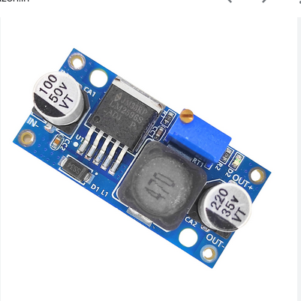

Fig No 2.6.1 Buck Converter.

**2.6.2 Voltage Regulation**

Voltage regulation ensures that all components receive the appropriate voltage levels necessary for proper functioning. In a rover setup, different components may have different voltage requirements, so voltage regulation is vital to avoid damaging any sensitive electronics.

**Components of Voltage Regulation**:

**Step-up and Step-down Converter:**

A DC-DC step-down (buck) converter can be used to reduce the voltage from the battery (e.g., 7.4V) down to the 5V required by the ESP32-CAM and Node MCU. If using a Li-Po battery (e.g., 7.4V), a buck converter can efficiently step this down to 5V, providing stable voltage for the Node MCU and ESP32-CAM, without wasting energy as heat. A step-up (boost) converter could also be used if a higher voltage (e.g., 12V) is required for the motor driver and motors, or if there are fluctuating power needs.

**Power Distribution Board (PDB):**

If your rover includes multiple components with different voltage needs, you may opt to use a power distribution board. This ensures that the correct voltage is supplied to each component.

The PDB would take the battery's input (e.g., 7.4V or 12V) and then split and regulate it into separate lines to supply 5V (for the Node MCU and ESP32-CAM) and 12V (for the motor driver and motors).

**Voltage Regulators for Motors:**

The L298N motor driver can work with 5V to 12V input, but since your 30 RPM motors are likely designed to operate at a specific voltage (e.g., 6V or 12V), you need to ensure that the voltage from the battery is stepped up or down accordingly to match the motor requirements. For instance: If using a 7.4V Li-Po battery, you may need to adjust the voltage to a stable 12V to run the motors efficiently. A step-down regulator can ensure that the voltage for the motors is regulated and stable, preventing damage to the motors or motor driver.

**Protection Circuitry:**

**Over-voltage protection**: A voltage protection circuit can be added to prevent the components from being exposed to voltages above their rated limit.

Overcurrent protection: Protects the battery and the power system from damage caused by excessive current draw.

**Monitoring:**

Integrating a voltage monitoring system can allow the user to check the remaining battery voltage, either through the display module on the rover or by sending notifications through the ESP32-CAM to the connected device. This ensures that the rover doesn’t run out of power unexpectedly.

**LCD Display Module:**

The LCD Display Module is a key component in providing real-time feedback to the user, enabling effective operation and monitoring of the Sentinel Rover.

**2.7.1** **Introduction:**

The LCD display serves as a crucial interface for users, displaying vital information about the rover's operational state, connectivity, and system health. This makes it easier to manage the rover remotely without constantly needing to rely on a smartphone or PC

### 2.7.2 Functionality and Interface

The **LCD module** communicates with the **Node MCU** and is used to display various essential data. In addition to the core functions, it offers several extra features that contribute to better user control and monitoring:

1. **IP Address**: Displays the **IP address** of the **ESP32-CAM** module, which is necessary for the user to connect to the rover via Wi-Fi for video streaming and remote control.
2. **System Status**: Provides continuous feedback on the rover’s **operational status**, ensuring the user is always informed about the rover's health and readiness.
3. **Battery Level**: Shows the **remaining battery charge**, helping the user keep track of the power levels and avoid unexpected shutdowns during use.
4. **Signal Strength**: Displays the current **Wi-Fi signal strength**, letting the user know if the rover is experiencing any connectivity issues and needs repositioning for better range.
5. **Movement Confirmation**: After each movement command (e.g., forward, backward, left, right), the display briefly shows a confirmation of the action being executed, ensuring the user knows that the command has been received.
6. **Temperature Monitoring**: If the system includes temperature sensors, the LCD can display the rover’s **internal temperature**, alerting the user to potential overheating, which could harm sensitive components like the ESP32-CAM or Node MCU.
7. **Wi-Fi Connection Status**: Shows if the rover is **connected** to the Wi-Fi network or not. If disconnected, it may display an alert prompting the user to reconnect. The **I2C interface** simplifies wiring and reduces the number of required pins, making it easy to integrate the LCD module into the compact rover design while minimizing wiring complexity.

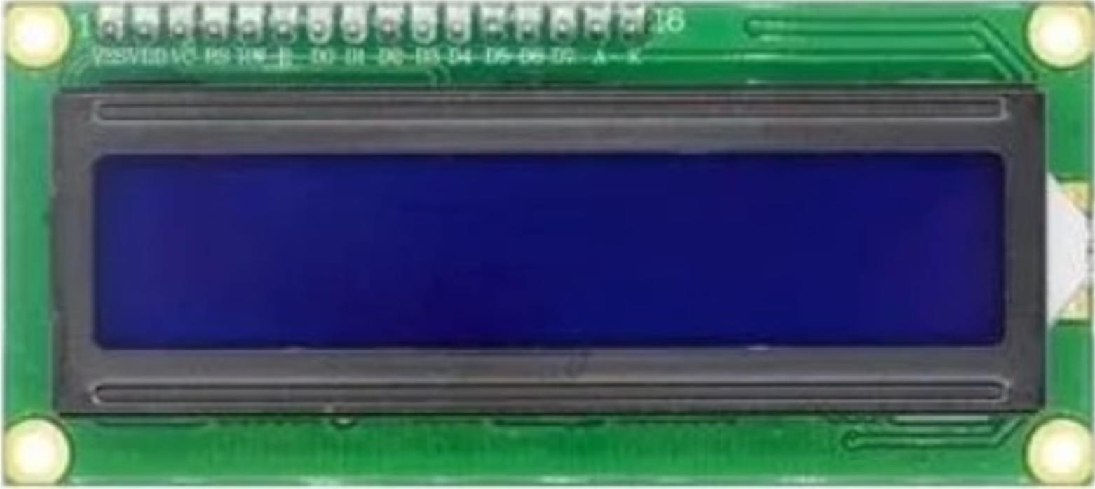

Fig No 2.7.2 LCD

**CHAPTER 3**

**DESIGN AND IMPLEMENTATON**

**3.1 Software Implementation:**

The Sentinel Rover's software implementation combines a user-friendly front-end interface with efficient communication and image processing capabilities. The ESP32-CAM, powered by OpenCV, performs real-time tasks like motion detection, object tracking, and anomaly recognition locally, minimizing latency. The processed data is transmitted via Wi-Fi to the user interface for enhanced monitoring. The Node MCU acts as the central hub, managing commands from the interface, controlling the motors, and processing image data for obstacle detection and navigation, enabling seamless, efficient remote operation and surveillance.

**3.1.1Front End Design:**

The **front-end design** focuses on the user interface (UI) that allows users to control the rover and view real-time video feeds. The front-end will likely be a mobile app or web-based interface, providing an easy way to interact with the rover's features.

* **Movement Controls**: The front-end will have buttons for basic movement commands: **forward, backward, left, right**. Each button sends corresponding commands to the **Node MCU** to control the motors via the **L298N motor driver**.
* **Video Streaming**: The user interface will display a live feed from the **ESP32-CAM**. The video will be streamed over Wi-Fi to the user’s device (smartphone or PC).
* **Status Indicators**: Display vital information like the rover’s **battery level**, **IP address**, and **connection status** to help the user monitor the rover's performance and connectivity.
* **User Feedback**: After issuing a movement command, the interface will show visual confirmation (e.g., "Moving Forward") or error messages if something goes wrong (e.g., "No Connection").

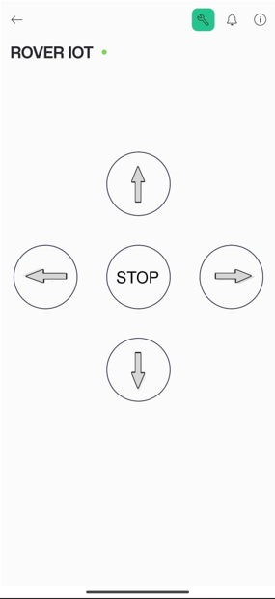

Fig No 3.1.1 Front End Design.

This **front-end design** is crucial for ensuring that the rover is user-friendly and provides clear, responsive controls while also displaying essential feedback for smooth operation.

### 3.1.2 Data Communication and Control

Effective **data communication and control** between the rover’s components (Node MCU, ESP32-CAM, motor driver) and the user’s interface is essential for real-time operation. The main focus here is ensuring the commands and video feed are transmitted smoothly over Wi-Fi.

#### Key Elements:

**1. Wi-Fi Communication**

The ESP32-CAM and Node MCU communicate over a Wi-Fi network, enabling seamless interaction with the user's mobile or PC app. The rover's IP address is displayed on an LCD for easy access.

* ESP32-CAM: Streams live video to the user’s device over Wi-Fi. The video data is transmitted in small chunks to ensure real-time viewing. The ESP32-CAM also utilizes OpenCV to process video frames locally, performing tasks such as motion detection, object tracking, and anomaly recognition before transmitting the results.
* Node MCU: Functions as the central controller, receiving user commands (e.g., movement instructions) sent over Wi-Fi from the front-end interface. It translates these commands into motor control signals for the L298N motor driver and processes image-based data from the ESP32-CAM for better decision-making.

**2. Command Execution**

The front-end interface allows the user to send movement commands (e.g., "move forward" or "turn left") to the Node MCU via Wi-Fi. These commands are processed by the Node MCU, which generates corresponding signals for the L298N motor driver. The motor driver then precisely controls the 30 RPM motors to execute the desired movements. Simultaneously, the Node MCU coordinates with the ESP32-CAM to ensure real-time image analysis, aiding in obstacle detection and navigation adjustments.

**3. Control Feedback**

As the rover moves, the Node MCU provides continuous feedback to the front-end interface. Status updates such as "Moving Forward" or "Turning Left" are relayed to keep the user informed about the rover's actions. Additionally, data from the ESP32-CAM’s image processing (e.g., detected obstacles or anomalies) is sent to the user’s device to enhance situational awareness.

**4. Error Handling**

The Node MCU incorporates error-handling mechanisms to ensure reliable operation. If an issue is detected, such as a motor failure, obstacle interference, or a weak Wi-Fi signal, the Node MCU sends an error message to the user’s device. Similarly, if the ESP32-CAM encounters issues in image processing (e.g., poor lighting conditions or data overload), alerts are sent, enabling timely troubleshooting and ensuring smooth functionality.

By combining Wi-Fi communication, efficient command execution, real-time image processing, and robust error handling, the Sentinel Rover delivers a reliable and responsive surveillance solution.

**3.1.3 Open CV:**

**2.2.2.3 Image Processing**

The Sentinel Rover employs OpenCV, a robust open-source computer vision library, to handle image processing tasks. OpenCV enables the rover to process images and analyze environmental data efficiently in real-time. Using algorithms like edge detection, motion detection, and object tracking, the rover identifies changes or anomalies in its surroundings, which are crucial for surveillance and monitoring applications.

Captured images are processed locally on the ESP32-CAM module, utilizing OpenCV to enhance features, detect contours, and filter noise for more accurate analysis. This localized processing reduces latency and allows the rover to function effectively even in environments with limited connectivity. The processed results are transmitted to the Node MCU, which updates the user interface with critical insights.

OpenCV’s versatility allows for the integration of advanced features, such as object recognition, environmental mapping, and future upgrades like AI-based detection. This ensures that the Sentinel Rover remains a scalable and adaptable solution for security, disaster response, and exploration tasks.

**3.2 Hardware Implementation:**

The hardware implementation of the Sentinel Rover integrates key components to ensure efficient operation, mobility, and image processing capabilities. The main hardware includes:

* **ESP32-CAM Module**: Captures real-time video and performs image processing tasks such as motion detection and object tracking using OpenCV.
* **Node MCU**: Functions as the central controller, managing communication, processing user commands, and coordinating motor control.
* **L298N Motor Driver**: Controls two 30 RPM motors, enabling precise navigation across various terrains.
* **30 RPM Motors**: Provide reliable mobility for the rover, designed for stability and efficiency.
* **LCD Display**: Displays the rover’s IP address, connectivity status, and error notifications for easy monitoring.

This combination of components ensures seamless communication, image processing, and movement for a reliable surveillance system.

**3.2.1 Design Of The Project:**

The Sentinel Rover is designed with a compact yet modular structure to ensure portability, efficiency, and adaptability.

* Mechanical Design: The chassis is lightweight and sturdy, housing the motors, sensors, and electronics securely. The design ensures balance for smooth movement on uneven surfaces.
* Electronic Design: The ESP32-CAM and Node MCU are connected for seamless data exchange over Wi-Fi. The L298N motor driver interfaces with the Node MCU to control motor movements. The LCD display is positioned for easy readability.
* System Integration: Image processing via OpenCV is performed locally on the ESP32-CAM, and data is transmitted to the Node MCU for decision-making and feedback updates. User commands from the front-end interface are translated into motor actions, with real-time feedback provided for effective control.

This design ensures a reliable, scalable system suitable for a range of surveillance and exploration applications.

**3.2.1.1 Circuit Diagram:**

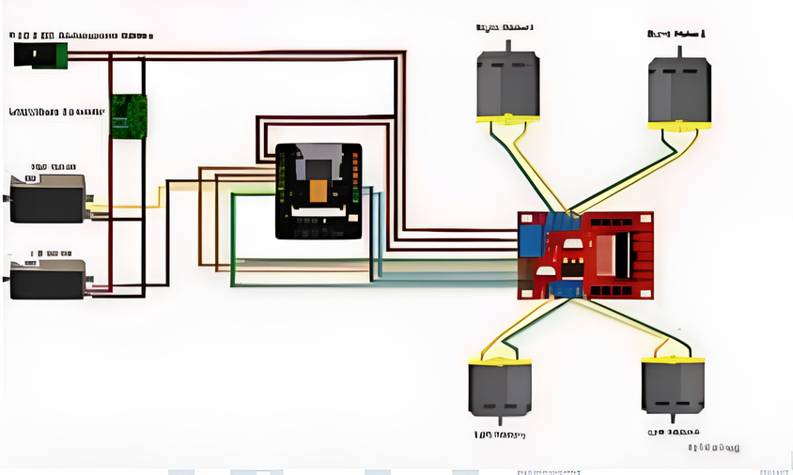

Fig No. 3.2.1.1 Circuit Diagram

**3.2.1.2 Working Of Circuit:**

**1. Power Supply and Regulation**

* The **Li-ion battery (7.4V or 12V)** provides power to the entire system.
* A **voltage regulator (AMS1117 3.3V or 5V)** ensures that the ESP32-CAM receives a **stable voltage** for proper operation.
* The **motor driver (L298N/L293D)** is directly powered by the battery, as motors require higher voltage and current.

**2. ESP32-CAM Module (Microcontroller & Video Streaming Unit)**

* The **ESP32-CAM** serves as the brain of the system, controlling all major functionalities:
  + **Captures real-time video** using its built-in camera.
  + **Streams video** via **Wi-Fi** to a smartphone, computer, or web-based interface.
  + **Sends control signals** to the motor driver to move the robot.
* If configured, **Bluetooth can also be used** for short-range manual control.

**3. Motor Driver (L298N or L293D) and DC Motors**

* The **ESP32-CAM sends PWM (Pulse Width Modulation) signals** to the motor driver module via its GPIO pins.
* The **motor driver receives these signals** and controls the **speed and direction** of the **DC motors** accordingly.
* **Motor Movement:**
  + **Forward Movement:** Both motors rotate forward.
  + **Backward Movement:** Both motors rotate in reverse.
  + **Left Turn:** Right motor moves while the left motor stops.
  + **Right Turn:** Left motor moves while the right motor stops.
  + **Stop:** Both motors stop.

**4. Wireless Communication (Wi-Fi & Bluetooth)**

* **Wi-Fi Mode:**
  + The ESP32-CAM connects to a network, enabling remote access via a mobile app or web interface.
  + Users can view the live **video stream** and send movement commands from their smartphone or PC.

**3.2.2 Implementation Of The Project:**

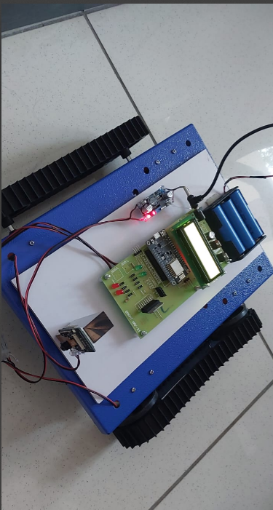

Fig No 3.2.2 Hardware Implementation

**OUTPUT:**

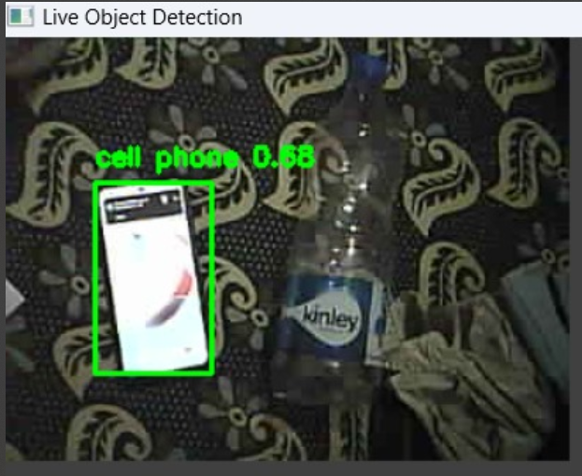

**CHAPTER 4**

**CONCLUSION AND FUTURE ENHANCEMENT**

**4.1 Conclusion:**

The Sentinel Rover is a cost-effective, compact, and versatile surveillance system designed for real-time monitoring in diverse environments. By integrating a **NodeMCU** for wireless communication, an **ESP32-CAM** for image processing, and an **L298N motor driver** for precise navigation, the rover provides an efficient solution for remote surveillance. Its ability to capture and analyze high-definition images makes it suitable for security monitoring, disaster response, and exploration in hazardous or inaccessible areas. The combination of affordability, portability, and functionality makes the Sentinel Rover a promising step toward accessible surveillance technology.**5.2 Future 4.2 Future Enhancement:**

1. **AI-Based Object Detection** – Integrating machine learning models for real-time recognition of objects, people, or anomalies.
2. **Night Vision & Thermal Imaging** – Adding infrared cameras or thermal sensors to enhance visibility in low-light conditions.
3. **Autonomous Navigation** – Implementing GPS and LiDAR for self-guided movement and obstacle avoidance.
4. **Long-Range Communication** – Using LoRa or 4G/5G modules to extend operational range beyond Wi-Fi coverage.
5. **Battery Optimization** – Implementing solar charging or energy-efficient motors for longer operation time.
6. **Environmental Adaptability** – Enhancing the rover with waterproofing and rugged materials for extreme conditions.

**REFERENCES**

[1] SURVEILLANCE ROBOT USING ESP32 CAM.

[2] IOT Surveillance Robot Using ESP-32 Wi-Fi CAM & Arduino [3] Surveillance Robot with ESP32 Camera by using Web Application- JETIR.Org [4] International Journal of Research Publication and Reviews Surveillance Monitoring Using ESP32-CAM Module [5] CCTV Surveillance: Video Practices and Technology" by Herman Kruegle [6] Physical Security Principles" by John E. Conklin [7] Network Security Essentials: Applications and Standards" by William Stallings [8] Organizations like ASIS International (https://www.asisonline.org/) [9] Security Industry Association (https://www.securityindustry.org/) [10] International journal of creative research Thoughts. [11] "Practical Electronics for Inventors" by Paul Scherz and Simon Monk [12] "Mastering Internet of Things" by Peter Waher. [13] "Internet of Things with ESP32" by Marco Schwartz and Agus Kurniawan. [14] "ESP32 for Busy People" by Satish Chandra Gupta [15] “Wireless Survelliance Robotic Car”published by 1Pramod Singh, 2Vimlesh Singh, 3Harsh Vardhan, 4Nandanee Maurya 5Ajay Sharma . [16] “Multipurpose Survelliance Robot ” published by Shraddha Londhe*1, Pooja Shinde*2, Sanket Mendke*3, Sahil Dhage*4, Prof. Dr. Niteen Futane*5 [17] published by Dr M Senthamil Selvi2 M.Faesa Fathima3 S.Dhivyuaa, 4 S.Mouriya [18] “ Surveillance monitoring using ESP32 Cam Module”Dr.P.D. selvam, K. Nikhil, K. Ranjitha reddy, A. Mounika, P. Reddy sekhar, M. Reddy siva sai. [19] “Web Controlled Survelliance Robot” Dev Jyoti Ghosh, Shaarang Sahane, Shreyash Bhandari, Vedant Shirale, and Mudit Kapoor [20] “An implementation on Surveillance Robot using Raspberry Pi Technology ”Zeeshan Shaikh ,Priyanka Gandhi, Nikhil Khare,Swapnil Kapade, Prof. M.V. Korade. [21] “IoT based Surveillance robot” published by Anandravisekar, . Anto Clinton, Mukesh Raj, Naveen.